**HOME WORK**

**Homework based on Lecture 4.1**

1. Which of the following is correct recurrence for worst case of Binary Search?  
   (A) T(n) = 2T(n/2) + O(1) and T(1) = T(0) = O(1)  
   (B) T(n) = T(n-1) + O(1) and T(1) = T(0) = O(1)  
   **(C) T(n) = T(n/2) + O(1) and T(1) = T(0) = O(1)**  
   (D) T(n) = T(n-2) + O(1) and T(1) = T(0) = O(1)
2. The algorithm like quicksort, merge sort and binary search are based on….  
   a) Greedy algorithm  
   b) Hash Table  
   **c) Divide and Conquer algorithm**  
   d) Parsing

**Homework based on Lecture 4.2**

1. Running merge sort on an array of size n which is already sorted is  
     
   a) O(n)  
   **b) O(nlogn)**  
   c) O(n2)  
   d) None
2. Consider the situation in which assignment operation is very costly. Which of the following sorting algorithm should be performed so that the number of assignment operations is minimized in general?  
     
   a) Insertion sort  
   **b) Selection sort**  
   c) Heap sort  
   d) None

**Homework based on Lecture 4.3**

1. Strassen’s matrix multiplication algorithm follows ___________ technique.  
   a) Greedy technique  
   b) Dynamic Programming  
   **c) Divide and Conquer**  
   d) Backtracking
2. What is the running time of Strassen’s algorithm for matrix multiplication?  
   **a) O(n2.81)**  
   b) O(n3)  
   c) O(n1.8)  
   d) O(n2)

**Homework based on Lecture 4.4**

1. Which of the following methods can be used to solve the Knapsack problem?  
   a) Brute force algorithm  
   b) Recursion  
   c) Dynamic programming  
   **d) Brute force, Recursion and Dynamic Programming**
2. You are given a knapsack that can carry a maximum weight of 60. There are 4 items with weights {20, 30, 40, 70} and values {70, 80, 90, 200}. What is the maximum value of the items you can carry using the knapsack?  
   **a) 160**  
   b) 200  
   c) 170  
   d) 90
3. The 0-1 Knapsack problem can be solved using Greedy algorithm.  
   a) True  
   **b) False**

**Homework based on Lecture 4.5**

1. Which of the following is true?  
   **a) Prim’s algorithm initialises with a vertex**b) Prim’s algorithm initialises with a edge  
   c) Prim’s algorithm initialises with a vertex which has smallest edge  
   d) Prim’s algorithm initialises with a forest
2. Consider the given graph.  
   [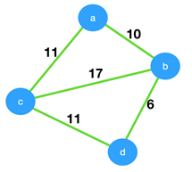](https://www.sanfoundry.com/wp-content/uploads/2018/07/prims-algorithm-questions-answers-q2.png)  
   What is the weight of the minimum spanning tree using the Prim’s algorithm,starting from vertex a?  
   a) 23  
   b) 28  
   **c) 27**d) 11
3. Consider the given graph.  
   [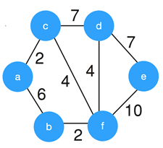](https://www.sanfoundry.com/wp-content/uploads/2018/07/kruskals-algorithm-questions-answers-q3.png)  
   What is the weight of the minimum spanning tree using the Kruskal’s algorithm?  
   a) 24  
   b) 23  
   c) 15  
   **d) 19**

**Homework based on Lecture 4.6**

1. Which of the following is true about Huffman Coding?  
   (A) Huffman coding may become lossy in some cases  
   (B) Huffman Codes may not be optimal lossless codes in some cases  
   **(C) In Huffman coding, no code is prefix of any other code.**(D) All of the above
2. Which of the following algorithms is the best approach for solving Huffman codes?  
   a) exhaustive search  
   **b) greedy algorithm**  
   c) brute force algorithm  
   d) divide and conquer algorithm
3. From the following given tree, what is the code word for the character ‘a’?  
   [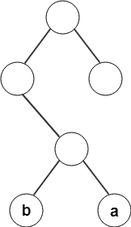](https://www.sanfoundry.com/wp-content/uploads/2018/07/huffman-code-questions-answers-q7.png)  
   **a) 011**  
   b) 010  
   c) 100  
   d) 101